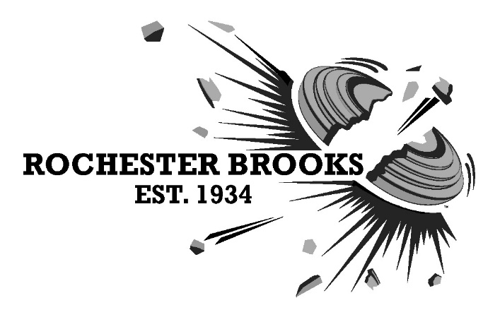
962 Honeoye Falls #6 Road, Rush, NY 14543 | (585) 533-9913 | www.rbgunclub.com

To whom it may concern:

This is to confirm that the following shooters are invited to attend the New York State Skeet Championships at Rochester-Brooks Gun Club, August 24-26, 2018. The competition starts on August 24, but shooters are advised to arrive at the club by Thursday August 23, 2018.

This competition is sponsored by the National Skeet Shooting Association, San Antonio, TX.

Please replace this text with your name and address

The registration forms for this shoot are also provided.

If anything further is required, please do not hesitate to contact me.

Sincerely,

Andrea Graham Lehr
Chairman, Rochester-Brooks NYS Skeet Championships
926 Honeoye Falls Road #6
Rush, NY 14543

Contact: agraham@rochester.rr.com

