Click here to enter your Name
Click here to enter your Street Address
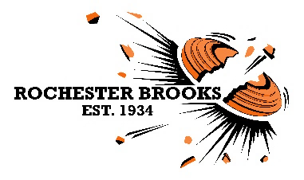
Click here to enter your City, Province & Zip Code

You are cordially invited to the

JANUARY 11th, 2020

NSCA Registered Event
NSCA fees included

Hunter Class & Walk-ins Welcome!

~ 100 Sporting Clay Targets ~

$50 - Adults ~ $30 - Juniors (12 - 21 years old)

SELF SQUAD, EUROPEAN START
Open 9 am, Last squad out -1:00 pm

~ 50 5-Stand Targets ~

$25 - Adults ~ $15 - Juniors (12 - 21 years old)

SELF SQUADDING EVENT - 5 MAN (max)

For additional information email: SportingClaysRegistration@yahoo.com
Club management reserves the right to change the program

Rochester Brooks Gun Club | 962 Honeoye Falls #6 Rd. | Rush, N.Y. | RBGunClub.com | (585) 533-9913

