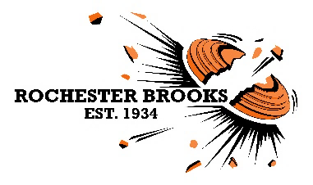
Click here to enter your Name
Click here to enter your Street Address
Click here to enter your City, Province & Zip Code

You are cordially invited to the

NOVEMBER 14th, 2020

NSCA Registered Events
NSCA fees included

100 EARLY BIRD TARGETS at 1 pm - $75

100 NIGHT OWL TARGETS* at 6 pm - $95
*Lighted Sporting Clays course

DINNER AT 4:00 PM INCLUDED FOR ENTRANTS OF BOTH EVENTS!
EVENTS ARE SQUADDED
REGISTER AT: www.winscoreonline.com

962 Honeoye Falls #6 Rd | Rush, NY 14543 | www.RBGunClub.com

