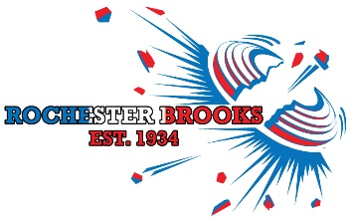
Click here to enter your Name
Click here to enter your Street Address
Click here to enter your City, Province & Zip Code

You are cordially invited to

For additional information email: Events@RBGunClub.com
Club management reserves the right to change the program
Rochester Brooks Gun Club | 962 Honeoye Falls #6 Rd. | Rush, N.Y. | RBGunClub.com | (585) 533-9913

