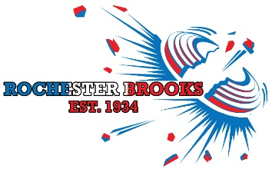
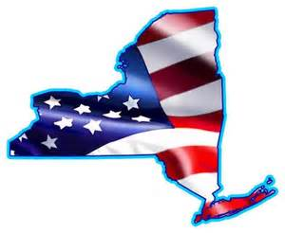
Click here to enter your Name
Click here to enter your Street Address
Click here to enter your City, Province & Zip Code

You are cordially invited to the
NEW YORK STATE CHAMPIONSHIP
JULY 24th – 26th, 2020
National Sporting Clays Association Registered Events, Fees included

All Events are Squadded and 5 man maximum

SUB GAUGE EVENT – 1 Event each Day
50 target event - $50
28ga - Friday
20ga - Saturday
12ga - Sunday

PRELIMINARY EVENT - *FRIDAY ONLY
100 target event - $80

MAIN EVENT - Saturday & Sunday
200 target event - $200
Three flight times: Sat 8:30am/Sun 11:30am, Sat 11:30am/Sun 2:30pm, Sat 2:30pm/Sun 8:30am,
ALL flights are limited to 80 shooters, *HOA & RU, excluded from class purses

For additional information email: Events@RBGunClub.com
Club management reserves the right to change the program
Rochester Brooks Gun Club | 962 Honeoye Falls #6 Rd. | Rush, N.Y. | RBGunClub.com | (585) 533-9913

