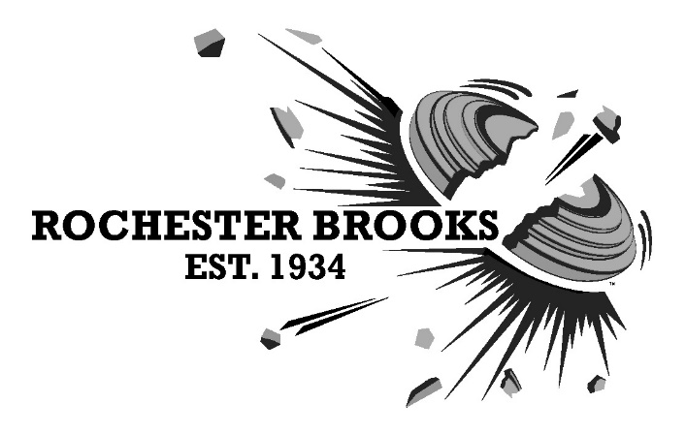
962 Honeoye Falls #6 Road, Rush, NY 14543 | (585) 533-9913 | www.rbgunclub.com

To whom it may concern:

This is to confirm that Click here to enter your Name is invited to attend the New York State Skeet Championships at Rochester-Brooks Gun Club on August 26-28, 2022.

If anything further is required, please do not hesitate to contact me.

Sincerely,

Andrea Graham Lehr
Chairman, Rochester-Brooks Skeet Committee
926 Honeoye Falls Road #6
Rush, NY 14543

Contact: agraham@rochester.rr.com

